Last updated 01.10.2025
Fire Risk Assessment Management Plan – Blenheim Court, Royal Wootton Bassett
The below relates to the FRA carried out in February 2025 and any unactioned points from the 2023 report
The below notes are to be used as general guidance only. Richard Tydeman, Tydemans Residential takes no responsibility for any inaccuracies in the below notes. These notes are taken from the FRA and the directors use them along with the actual FRA to plan actions to mitigate risks. As the responsible persons for the fire safety of the building, the directors and members of the management company, CH Flats No 1 Wootton Bassett Ltd must read the FRA fully and understand the requirements so they can make an informed decision about how to progress. The assessor is also happy to take a call to discuss any issues if required.
Below you will find 2 points outstanding from the previous FRA dated 2023 that are ongoing. This is followed by the most recent report dated 2025 and following this are the actions taken to mitigate risks in the 2023 report.
Yellow indicates action to be taken or decisions required. Grey is a completed section.
Items not completed from the FRA dated 2023 have been added to the below list

Items From Report Dated February 2025 (Current report)
No 1 – Portable Appliances
There were no PAT test records for hoovers. PAT test is required for any appliances left on site.
Suggested Action: Contact cleaners to see if they use the appliances on site and if they do, get Pat test carried out asap. If not, then remove items.
Action Taken: Karen who completes the cleaning advised she does not use the hoovers. The carpet cleaner is hers and is used on occasion. All items will be removed from the building.
Outcome: Update March 2025. All appliance have been removed from site. Complete.
___________________________________________________________________
No 2 – Fire Exit Cage
The FRA states “The Assessor noted that the stable bolt was very stiff to operate on the ground floor right hand corridor metal cage exit door. The RP must ensure this stable bolt can be released with effort. So, building occupants can use this as a fire exit.”
Suggested Action: This issue was highlighted previously on a visit by R Tydeman. I suggest we remove the cage/fire exit external cage door OR repair it asap.
Action Taken: Update 05.03.25 Contractor has been instructed to make changes to the hinge end of the cage door to allow it to close without springing out. Also to make adjustments with the bolt to make sure it can be opened and closed easily
Update 14032025: Management committee met at the site on 10/03/2025 to review the entire block, look at these issues and see in person the problems faced. A surveyor is attending at the end of march (31st) to provide a full building survey due to many other issues and once completed they will look at a way to manage these problems in the safest and most financially feasible way possible. It was agreed to remove the cage due to its condition and the risks posed and dispose of. Contractors have been requested to carry this out.

Outcome: March 20th 2025: Cage has been removed and disposd of. Upon removal it was reviewed to see if it could be saved however the metalwork has degraded too far. This risk has been removed and is now complete.
___________________________________________________________________

No 3 – Communal and Individual Flat Doors
The FRA states “The RP must ensure that all common fire doors and each flat entrance fire doors are FD30S fire doors, with working self-closer (not required for locked cupboards), and are fit for purpose in accordance with BS 8214:2016, manufactures instructions. And being inspected as a minimum as per Regulation 10 under the Fire Safety (England) Regulation 2022. Fire Safety Services have completed fire door inspections of all common area fire doors; however, no flat fire doors were Assessed because no residents responded when knocking to access their door. The condition of the fire doors inspected has been documented with faults under a separate fire door inspection report dated September 2024. The RP must ensure that they notify residents of the condition of the fire doors. And advise them that their flat entrance door must be a FD30S fire door with working self-closer. And the RP and the residents where necessary, must ensure the fire door remediations works within the report are completed within a defined timeframe, and all fire doors are fit for purpose. Which is not the case at the time of the Assessment.
Suggested Action: Advise all residents and owners of the above information and the requirements for their flat doors. To act upon the communal door report that was prepared and remedy defects within a defined timeframe. This links into point 7 and 10 and 11.
Action Taken: update 05.03.25 - Letters have been issued to all owners advising them of what is required regarding their front doors (copies can be found on Tydemansresidential.co.uk). Links have been included to the FRA for them to review and this is to be issued annually with all service charges.
At the same time, a letter will be issued annually to all residents which will include similar information. This will mean all occupiers get a copy (whether they live in or rent the property). All new owners will have access to this information via the LPE1 forms which will be completed upon purchase and at the outset of their ownership.
Directors to approve content of a letter to issue and distribute accordingly to residents (owners have already been written to) and so make this a yearly item to action.
A quote has been obtained from Abbey fire to remedy the communal doors (top floor is £3877.50 inc VAT for just the doors plus further £4,000-£5,000 +VAT for the cabinet area). Given the financial constraints a quote for just the top floor has also been provided with the aim to complete the works over 3 years a floor at a time. A 2nd quote is awaited from Morton Contractors.
Update: 07032025: Morton Contruction have provided quotes for the work. They would include this work within the communal door works to minimise costs. They have advised the costs would be £6480 inc VAT to remedy the cabinets and door issues on the 1st and 2nd floor. Ground floor will be an additional £3000 due to having 4 further doors/areas to secure.
Update 14032025: Management committee met at the sit on 10/03/2025 to review the entire block, look at these issues and see in person the problems faced. A surveyor is attending at the end of march (31st) to provide a full building survey due to many other issues and once completed they will look at a way to manage these problems in the safest and most financially feasible way possible.
Update 22nd May 2025: Survey has been received. Meeting to be held in June to discuss way forward know the directors are aware of the extent of the buildings issues. Copy of survey available on site. In the meantime it has been approved for an electrical cabinet and adjacent door PLUS further communal doors to be repaired/replaced on the top floor. This was a level deemed most at risk and would allow the directors to begin a project of fire safety improvements while considering the best approach to resolve the noted items. Work at adjacent block to be compelte by 26.05.2025 – once complete if to a good standard the contractor will be approached to complete the work at Blenheim Court unless another suitable contractor is located. Further the intercom system will be upgraded to include a wireless system and this will allow the removal of many cables through frames thus further mitigating risk across the entire building. The contractor is installing again at an adjacent block and if this works we will request they or a suitable contractor replicates this work at Blenheim. This will hopefully be instructed within the next 3 weeks.

Update June 2025: Letter issued to all owners on 17/07/2024 and 07/02/2025 to advise regarding responsibilities around fire door safety. Copies also on website. Further fire safety information notice put up at the block advising what is needed surrounding fire door safety for flats and copy on website.
Directors have agreed to begin replacing communal doors with sign off given from FRA assessors on completion. The top floor electrical cupboard, storage cupboard and communal hallway doors are deemed most important due to being the highest thus will be completed first within this budget. If further funds are available the next floor will be expedited however we expect all floors to be compliant within 2 years (24.25 budget, 25.26 budget, 26.27 budget). Top floor is scheduled 8th August 2025.
Update September 2025: Top floor electrical cupboard has been built and is awaiting signoff. Top floor cupboard to roof space has been completed and awaiting signoff. Work on final top floor corridor door and surround is being carried out on 12th Sept 2025 and will then be signed off. Further works to other floors will be diarised once this level is complete.
Update October 2025: Top floor electrical cupboard and storage cupboard on landing has been signed off as compliant by Secure Safety Solutions. Report dated 04/09/25. Corridor door and frame being replaced fully towards end of Early Oct.

Outcome:
___________________________________________________________________

No 4 – Compartmentation – Smoke Seals Electrical Cabinets
This issue was highlighted in the 2023 report as well as the 2025 report
FRA states “On each floor level there are metal electrical cabinets. Whilst the metal electrical cabinets might provide a 30-minute fire rating, there was no information to confirm this, plus there was limited smoke seals on the access doors. The RP must ensure that these cabinets are 30-minute fire rated, and the access doors have a form of smoke control and a kept secured with controlled access. Plus, where any cables exit the gaps must be fire stopped with a suitable intumescent product”
Suggested Action: Review the condition of the cabinets and assess whether seals can be applied to them other means to make safe
Action Taken: The cabinets have been reviewed and do not appear to be serviceable or repairable. Seals cannot guarantee to fit all around due to warping and age. Other aspects are being considered.
Update Feb 2025 - Pete Jolley (FRA assessor) has given an indication of £4k-£5k + VAT per cabinet to build a new cabinet around and move corridor door to allow access. Directors to consider.
Update 05.03.2025 – Morton Contractors who were recommended by another FRA assessor to provide a quote to remedy the electrical cabinet issue. Duncan will provide this asap.
Update: 07032025: Morton Contruction have provided quotes for the work. They would include this work within the communal door works to minimise costs. They have advised the costs would be £6480 inc VAT to remedy the cabinets and door issues on the 1st and 2nd floor. Ground floor will be an additional £3000 due to having 4 further doors/areas to secure.
Update 14032025: Management committee met at the site on 10/03/2025 to review the entire block, look at these issues and see in person the problems faced. A surveyor is attending at the end of march (31st) to provide a full building survey due to many other issues and once completed they will look at a way to manage these problems in the safest and most financially feasible way possible.
Update 22nd May 2025: Survey has been received. Meeting to be held in June to discuss way forward know the directors are aware of the extent of the buildings issues. Copy of survey available on site. In the meantime it has been approved for an electrical cabinet and adjacent door PLUS further communal doors to be repaired/replaced on the top floor. This was a level deemed most at risk and would allow the directors to begin a project of fire safety improvements while considering the best approach to resolve the noted items. Work at adjacent block to be compelte by 26.05.2025 – once complete if to a good standard the contractor will be approached to complete the work at Blenheim Court unless another suitable contractor is located. Further the intercom system will be upgraded to include a wireless system and this will allow the removal of many cables through frames thus further mitigating risk across the entire building. The contractor is installing again at an adjacent block and if this works we will request they or a suitable contractor replicates this work at Blenheim. This will hopefully be instructed within the next 3 weeks.

Update June 2025: Directors have agreed to begin replacing communal doors with sign off given from FRA assessors on completion. The top floor electrical cupboard, storage cupboard and communal hallway doors are deemed most important due to being the highest thus will be completed first within this budget. If further funds are available the next floor will be expedited however we expect all floors to be compliant within 2 years (24.25 budget, 25.26 budget, 26.27 budget). Top floor is scheduled 8th August 2025.
Update September 2025: Top floor electrical cupboard has been built and is awaiting signoff. Top floor cupboard to roof space has been completed and awaiting signoff. Work on final top floor corridor door and surround is being carried out on 12th Sept 2025 and will then be signed off. Further works to other floors will be diarised once this level is complete.
Update October 2025: Top floor electrical cupboard and storage cupboard on landing has been signed off as compliant by Secure Safety Solutions. Report dated 04/09/25. Corridor door and frame being replaced fully towards end of Early Oct.

Outcome:

___________________________________________________________________

No 5 – Compartmentation – Cables running through cabinets
This issue was highlighted in the 2023 report as well as the 2025 report
FRA states “The RP must ensure that each of the electrical cabinets where cables pass through fire resisting construction have been fire stopped. At the time of the assessment, it was noted with some, where cables pass through fire resisting construction which has not been fire stopped. The RP must ensure a survey of these areas is completed, and the RP takes the necessary action to reduce the risk and ensure these areas are adequately fire stopped with a suitable intumescent product which complies with BS EN 1366 Fire resistance service installations with a minimum 30-minute fire rating”
Suggested Action: This issue goes hand in hand with point no 4 and both will be resolved within the same work
Action Taken: Please see point no 4
Update 22nd May 2025: Survey has been received. Meeting to be held in June to discuss way forward know the directors are aware of the extent of the buildings issues. Copy of survey available on site. In the meantime it has been approved for an electrical cabinet and adjacent door PLUS further communal doors to be repaired/replaced on the top floor. This was a level deemed most at risk and would allow the directors to begin a project of fire safety improvements while considering the best approach to resolve the noted items. Work at adjacent block to be compelte by 26.05.2025 – once complete if to a good standard the contractor will be approached to complete the work at Blenheim Court unless another suitable contractor is located. Further the intercom system will be upgraded to include a wireless system and this will allow the removal of many cables through frames thus further mitigating risk across the entire building. The contractor is installing again at an adjacent block and if this works we will request they or a suitable contractor replicates this work at Blenheim. This will hopefully be instructed within the next 3 weeks.
Update June 2025: Directors have agreed to replace the intercom system which remove much of the cabling within the building. It will allow doors to be replaced with no cables going through frames so is being completed before door repairs and this is scheduled for July 2025.
Update September 2025: Wireless intercom system has been put in place – all cables relating to intercom connections have been removed from cabinets, corridors and communal door frames. Only remaining cables are cctv and electrical and will be signed off by an FRA assessor once the electrical cabinets are completed.
Update October 2025: Top floor electrical cupboard and storage cupboard on landing has been signed off as compliant by Secure Safety Solutions. Report dated 04/09/25. Corridor door and frame being replaced fully towards end of Early Oct.

Outcome:
___________________________________________________________________

No 6 – External Cladding
Despite the building being under 18m high it is recommended in the FRA that the cladding have an external wall survey to make sure it satisfies building regulations and is compliant (along with fitted fire barriers to windows).
Suggested Action: This one is difficult because I would assume the building was built to the building regs at the time the cladding was installed. New materials are now available (fire resistant) and with the recent events in London the cladding should be replaced over time regardless. This would also help areas that are poor fitting and have little insulation.
Action Taken: Directors to discuss and decide upon a course of action for this section. Directors to decide.
Update 14032025: Management committee met at the site on 10/03/2025 to review the entire block, look at these issues and see in person the problems faced. A surveyor is attending at the end of march (31st) to provide a full building survey due to many other issues and once completed they will look at a way to manage these problems in the safest and most financially feasible way possible.
Update May 2025: An FRA assessor has confirmed a EWS1 is not required as has a surveyor due to the building being under 11m (approx. 9m). HOWEVER, they have given instructions for the best products to use to replace the cladding if this is to be considered– this will also help resolve a number of issues per the survey carried out in April 2025.
Update Sept 2025: Cladding replacement project to be budgeted for
Outcome:
___________________________________________________________________

No 7 – Fire Safety Guidance for residents
FRA states “The RP must ensure that there is communication, coordination, and cooperation with the leaseholders and residents, and they are both aware of their action to take in the event of a fire and the stay put policy. The following information should be made available to all residents within the flats:- a) Fire safety instruction should be in comprehensible form that residents can be reasonably expected to understand. b) The evacuation strategy for the building. c) Provide fire safety information on how to report a fire and the action to take once a fire has occurred. d) The instructions should be to new residents as soon as reasonably practicable. e) The instructions should be issued to all residents within each period of 12 months. f) After any material changes the instructions should be issued to all residents. g) Provide information to residents on the importance of fire doors”
Suggested Action: Include this information yearly as with point 3, 10 and 11.
Action Taken: Letters need to be issued to all owners and residents with fire evacuation procedures etc per the above notes. This is to be included within eh yearly service charge letter and also a mailshot through residents doors once a year to capture all owners and occupiers. Directors to approve sending of a letter and contents.
Outcome: Notice has been added to the notice board detailing action to take, policy, who is responsible for fire safety and information about fire doors. Notice also added to website and all owners aware to review site for important information per previous letters.

___________________________________________________________________

No 8 – Signage
FRA states” The RP should ensure electrical hazard warning and fire door keep locked signs are affixed to the electrical metal cabinets access doors on each floor.”
Suggested Action: Purchase signage and affix to cupboards
Action Taken: Update 11032025: Signage has been purchased to be affixed to cabinets. No smoking for corridors, fire door keep shut for cupboards and electrical hazard for cabinets.
Outcome: Update 20th March 2025. No smoking signs, fire door keep shut signs and electrical hazard signs have all been added to relevant doors, and windows, Complete.
Examples below;
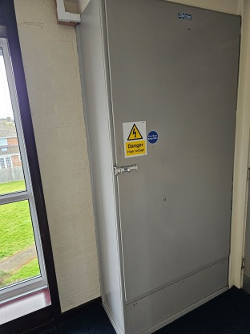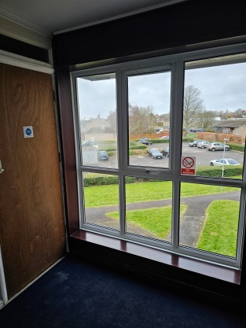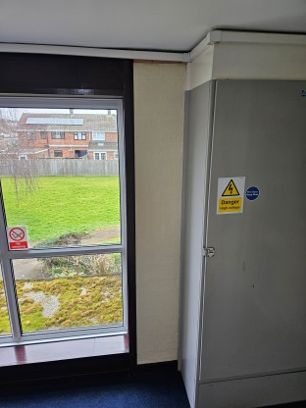

___________________________________________________________________

No 9 – Fire Safety Manager
FRA states “This block of flats and the common areas must be managed as per current fire safety guidance See here for guidance. Please also see this guidance ref the Responsible Person responsibilities. The RP must appoint a fire safety manager to implement and mange this FRA.”
Suggested Action: I would suggest that a director be this named person. The management company if the RP (responsible person) so this would make sense to make sure all actions are reviewed and dealt with.
Action Taken: Email sent to directors indicating a named person is required. Outcome awaited
Outcome: Update 14032025: Management committee met at the sit on 10/03/2025 to review the entire block, look at these issues and see in person the problems faced. The live and current directors of the management company are the named persons. Complete.
___________________________________________________________________

No 10 – Fire door maintenance for residents and owners
FRA states “Fire Doors - Under the Fire Safety (England) Regulations 2022, leaseholder and residents must be informed about the importance of maintaining fire doors in good condition and inform them they must be inspected annually. It must be stressed to them all flat entrance doors must be kept shut when not in use and, if they remove the self-closing device, they are breaking the law. They should be advised not to alter doors or replace existing doors without seeking professional advice. If they replace a fire-resisting door with a non-fireresisting door, they are also breaking the law. They must be told to report any faults or damage to their flat entrance door to the building fire / block manager immediately. It is a legal requirement that the above information be provided to residents as soon as reasonably practicable after they move into their flat, and at periods of no greater than 12 months thereafter. The RP must ensure this information is being promulgated annually to all residents.”
Suggested Action: Include this information yearly as with point 3 and 7 and 11. Owners have already been provided the link to tydemansresidential.co.uk to read the FRA and also various letters sent. This did not though include residents.
Action Taken: Letters need to be issued to all owners and residents with the above notes. This is to be included within the yearly service charge letter and also a mailshot through residents doors once a year to capture all owners and occupiers. Directors to approve sending of a letter and contents.
Outcome: Notice has been added to the notice board detailing action to take, policy, who is responsible for fire safety and information about fire doors. Notice also added to website and all owners aware to review site for important information per previous letters.
___________________________________________________________________

No 11 – Fire door suitability
FRA states “The RP must ensure that all common fire doors and each flat entrance fire door are inspected as per Fire Safety (England) Regulation 22 and they are compliant in accordance with BS 8214:2016, or the manufactures instructions to ensure they are FD30S fire doors. The RP must ensure the common area fire doors are fire for purpose, and inform the leaseholders too, their flat entrance doors must be FD30S (smoke) fire doors with self-closer and are being inspected and suitability maintained.”
Suggested Action: All communal doors have been inspected and recommendations made. Quotes to remedy defects underway. This should be a yearly check and budgeted for. Owners to be notified about their responsibilities and the fire door requirements. This links to points 3,7 and 10.
Action Taken: Letters have been issued to all owners advising them of what is required regarding their front doors (copies can be found on Tydemansresidential.co.uk). Links have been included to the FRA for them to review.

Outcome: Notice has been added to the notice board detailing action to take, policy, who is responsible for fire safety and information about fire doors. Letter issued to all owners. Copy on website.
___________________________________________________________________

No 12 – Contractor & Hot Works Policy
The building requires these 2 policies and a link in the report helps to give guidance about the production of these. Link is Using contractors: A brief guide INDG368(rev1)
Suggested Action: A policy needs to be drawn up for both the contractors and hot works.
Action Taken: I have made enquiries to see if generic policies are available but this does not seem to be the case. Directors to draw up set of policies for the blocks.
Outcome: Update March 2025: Andrew Wilkinson from Secure Safety Solutions (Senior Safety Consultant) and FRA assessor has provided documents that we could amend which he confirms are legally compliant – contractors policy, hot works and hot works permit. All of which have been added to the site for this property. Complete.

___________________________________________________________________

No 6 from Feb 2023 report – Compartmentation – Excessive gaps under cupboard doors
The gaps below the cupboard doors are deemed excessive and greater than the 8-10mm tolerance.
Suggested Action: Builder or contractor required to visit site and provide a quote to fit a drop down smoke seal to make these safe
Action Taken: Abbey Fire has been instructed to provide us with a full communal door report detailing all defects. Quote has arrived, Quote No, 13201 at £15,261.48 inc VAT to resolve all issues identified in report. Work needs reviewing and booking in. (updated January 2025)
Abbey fire was requested in Feb 2025 to quote for just the top floor with the aim to carry out works a floor a year, starting at the top which was deemed most at risk. Quote from Abbey Fire for top floor communal door and cupboard remedial work is quote no 13460 and £3877.50 inc VAT. Directors to consider moving ahead with this.
Update 05.03.25 - A 2nd quote is awaited from Morton Contractors.
Update 22nd May 2025: Survey has been received. Meeting to be held in June to discuss way forward know the directors are aware of the extent of the buildings issues. Copy of survey available on site. In the meantime it has been approved for an electrical cabinet and adjacent door PLUS further communal doors to be repaired/replaced on the top floor. This was a level deemed most at risk and would allow the directors to begin a project of fire safety improvements while considering the best approach to resolve the noted items. Work at adjacent block to be compelte by 26.05.2025 – once complete if to a good standard the contractor will be approached to complete the work at Blenheim Court unless another suitable contractor is located. Further the intercom system will be upgraded to include a wireless system and this will allow the removal of many cables through frames thus further mitigating risk across the entire building. The contractor is installing again at an adjacent block and if this works we will request they or a suitable contractor replicates this work at Blenheim. This will hopefully be instructed within the next 3 weeks.
Update September 2025: Top floor electrical cupboard has been built and is awaiting signoff. Top floor cupboard to roof space has been completed and awaiting signoff. Work on final top floor corridor door and surround is being carried out on 12th Sept 2025 and will then be signed off. Further works to other floors will be diarised once this level is complete.
Update October 2025: Top floor electrical cupboard and storage cupboard on landing has been signed off as compliant by Secure Safety Solutions. Report dated 04/09/25. Corridor door and frame being replaced fully towards end of Early Oct.

Outcome:
___________________________________________________________________
___________________________________________________________________
___________________________________________________________________
___________________________________________________________________
___________________________________________________________________

Historic Report Data From 2023 Report & Actions Taken
Fire Risk Assessment Management Plan – Blenheim Court, Royal Wootton Bassett
The below relates to the FRA carried out in 2023
The below notes are to be used as general guidance only. Richard Tydeman, Tydemans Residential takes no responsibility for any inaccuracies in the below notes. These notes are taken from the FRA and the directors use them along with the actual FRA to plan actions to mitigate risks. As the responsible persons for the fire safety of the building, the directors and members of the management company, CH Flats No 1 Wootton Bassett Ltd must read the FRA fully and understand the requirements so they can make an informed decision about how to progress. The assessor is also happy to take a call to discuss any issues if required.
It was noted in the assessment that a fire had occurred at Blenheim Court with the following comments so it is very important all issues are dealt with;

“There has been a fire incident at this premise previously. The cause of the fire was determined to have been bad housekeeping.”

No 1 – Compartmentation – Flat 22 Front Door
Flat 22 front door is deemed unfit for purpose and needs replacing.
Suggested Action: The owner of flat 22 should be advised that the door is not safe per the FRA and that they should take immediate steps to replace it.
Action Taken: 07/02/25 – Owner has been emailed and copy of report extracted and included within email.
Outcome: Update 07/02/25 – Owner has been advised and they should replace the door as recommended. Complete
___________________________________________________________________
No 2 – Compartmentation – Self Closing Devices
The FRA states that all flats should be provided with self closers to ensure they close when flats are left in a hurry.
Suggested Action: I would suggest that rather than CH Flats provide a closer that each flat is reminded of their obligations to make sure the front door is an FD30 door with all suitable safety precautions taken. The door is the responsibility of each individual owner. This is the same manner in which Wesley and Marlborough Court have taken so seems a reasonable approach here.
Action Taken: Update 07/02/25 – Draft letter has been written guiding all owners to review the FRA and actions within, specifically referring back to the doors issue highlighted. It is for owners to make sure these actions are taken as it is the responsibility of each owner to make sure their door is safe and meets all regulations. Committee to review letter, amend and agree for it to be issued.
Outcome: Update 12/02/2025 – Letter has been agreed to be sent to all owners. Instructions for letter to be issued 12/02/2025. This section is now complete and owners are expected to comply with all legislation as per the letter & FRA. New owners will also have sight of this document via their solicitors upon purchase of a property.
___________________________________________________________________

No 3 – Compartmentation – Smoke Seals Electrical Cabinets
The electrical cupboards do not have suitable smoke seals to stop smoke in the event of a fire from escaping the cabinets and blocking escape routes
Suggested Action: Review the condition of the cabinets and assess whether seals can be applied to them. The seals must fit tightly all around and be of a suitable fire resistant material.
Action Taken: The cabinets have been reviewed and do not appear to be serviceable or repairable. Seals cannot guarantee to fir all around due to warping and age. Other aspects are being considered.
Pete Jolley (FRA assessor) has given an indication of £4k-£5k + VAT per cabinet to build a new cabinet around and move corridor door to allow access. Directors to consider.
Being dealt with as part fo the 2025 report.
Outcome:
___________________________________________________________________

No 4 – Compartmentation – Hole in Ground floor cabinet
There is a hole in the cabinet on the ground floor which could allow smoke to escape
Suggested Action: Builder or contractor required to visit site and provide a quote to cover this hole with a suitable material. I would suggest a small metal plate as its too big for a sealant.
Action Taken: Contractors asked to investigate and resolve
Outcome: 13.02.25 – Fire plate affixed to area concerned and situation resolved. Complete

___________________________________________________________________

No 5 – Compartmentation – Lock on top floor electrical cabinet
The lock on the top floor electrical cupboard has been damaged and needs replacing
Suggested Action: Builder or contractor required to visit site and provide a quote to replace the lock
Action Taken: Contractor has been asked to review and quote to repair
Outcome: Lock has been changed. This item is now complete. (January 2025)
___________________________________________________________________

No 6 – Compartmentation – Excessive gaps under cupboard doors
The gaps below the cupboard doors are deemed excessive and greater than the 8-10mm tolerance.
Suggested Action: Builder or contractor required to visit site and provide a quote to fit a drop down smoke seal to make these safe
Action Taken: Abbey Fire has been instructed to provide us with a full communal door report detailing all defects. Quote has arrived, Quote No, 13201 at £15,261.48 inc VAT to resolve all issues identified in report. Work needs reviewing and booking in. (updated January 2025)
Abbey fire was requested in Feb 2025 to quote for just the top floor with the aim to carry out works a floor a year, starting at the top which was deemed most at risk. Quote from Abbey Fire for top floor communal door and cupboard remedial work is quote no 13460 and £3877.50 inc VAT. Directors to consider moving ahead with this.
Outcome:
___________________________________________________________________

No 7 – Compartmentation – Holes Through walls
A number of holes appear to be in walls outside of flats and breach compartmentalisation requirements.
Suggested Action: Review holes ourselves and if found not to be sealed request a builder or contractor to visit site and provide a quote to seal with suitable fire rated material.
Action Taken: Update January 2025 – To visit site and review holes and report findings.
Outcome: Update February 2025 – The holes are actually metal and capped metal so there are no holes going into flats. The only issue I could see was one cap has an area around the outside of the metal tube that “could” lead to a flat so I believe needs to be filled with fire proof sealant as its such a small hole (mm in size). The tube being metal will not melt and as such this I hope would satisfy any inspections. Builder to be asked to complete this work. Photos are detailed below of the “pipes”.
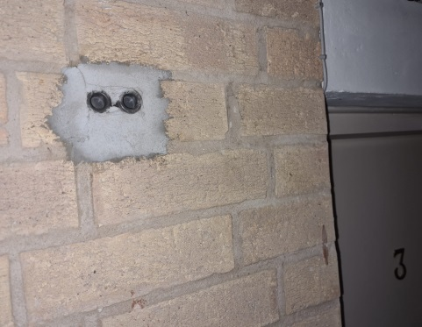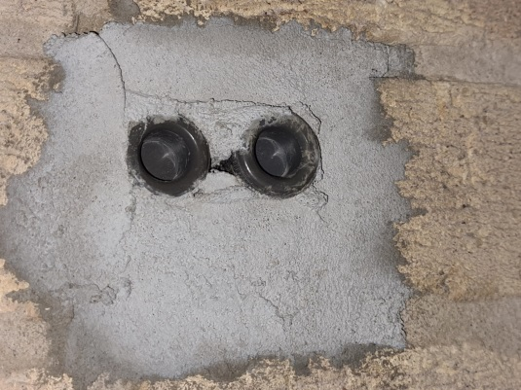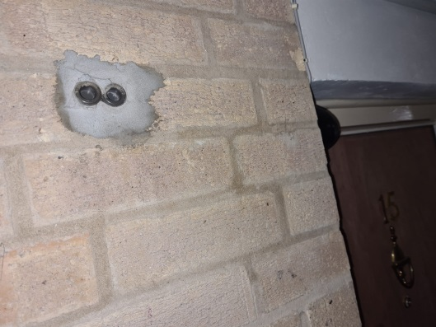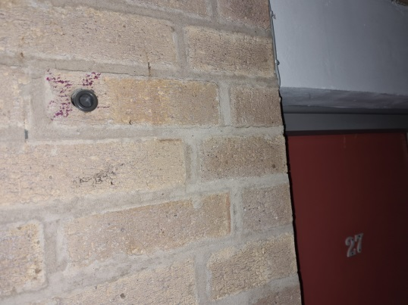
Update 13.02.25 – Small hole between brickwork and pipe filled. Contractror could not see any other gaps to cause concern and also confirmed pipes are blocked and capped ends. Complete.

___________________________________________________________________

No 8 – Compartmentation – Office Frame
The door frame in the office has been left bare and thus not fire safe
Suggested Action: Builder or contractor required to visit site and provide a quote to affix a strip of plasterboard and coat with plaster as per the FRA recommendations.
Action Taken: Builder to review and price for plasterboard and layer of plaster
Outcome: 12.02.25 – Area has been boarded with pink fireboard as precautionary along with a coating of plaster. Complete
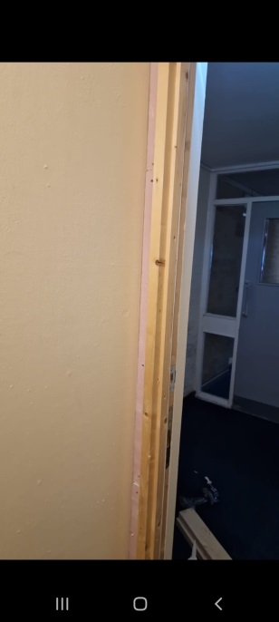

___________________________________________________________________

No 9 – Letter Boxes
All flats should have a suitable letterbox with intumescent seals. The notes state that management has previously provided information to leaseholders about this but only some have been replaced.
Suggested Action: All leaseholders to be written to advising them of the need to have these letterboxes installed. Also guidance to be issued annually within AGM notes so all existing and new owners have sight of these documents. Or directed to review FRA and the requirements.
Action Taken: Update 07/02/25 – Draft letter has been written guiding all owners to review the FRA and actions within, specifically referring back to the doors issue highlighted. It is for owners to make sure these actions are taken as it is the responsibility of each owner to make sure their door is safe and meets all regulations. Committee to review letter, amend and agree for it to be issued.
Outcome: Update 12/02/2025 – Letter has been agreed to be sent to all owners. Instructions for letter to be issued 12/02/2025. This section is now complete and owners are expected to comply with all legislation as per the letter & FRA. New owners will also have sight of this document via their solicitors upon purchase of a property.
___________________________________________________________________

No 10 – Compartmentation – Mortice Lock Covers
Some flat doors have mortice locks however the cover is not adequate and should be steel.
Suggested Action: All leaseholders to be written to advising them of the need to have these particular covers installed. Also guidance to be issued annually within AGM notes so all existing and new owners have sight of these documents. Or directed to review FRA and the requirements..
Action Taken: Update 07/02/25 – Draft letter has been written guiding all owners to review the FRA and actions within, specifically referring back to the doors issue highlighted. It is for owners to make sure these actions are taken as it is the responsibility of each owner to make sure their door is safe and meets all regulations. Committee to review letter, amend and agree for it to be issued.
Outcome: Update 12/02/2025 – Letter has been agreed to be sent to all owners. Instructions for letter to be issued 12/02/2025. This section is now complete and owners are expected to comply with all legislation as per the letter & FRA. New owners will also have sight of this document via their solicitors upon purchase of a property.
___________________________________________________________________

No 11 – Maintenance - EICR
An EICR is required (electrical safety inspection) every 5 years. The current EICR is dated 24th August 2023.
Suggested Action: No action required until 2028.
Action Taken:
Outcome: Ongoing – Every 5 Years. Complete at this time.
___________________________________________________________________

No 12 – Sign – Fire Exit sign
A slide to open sign is required on the rear fire escape cage.
Suggested Action: Builder or contractor required to visit site and provide a quote to affix Slide To Open sign to cage.
Action Taken: Update 10/02/25 – Slide to open sign has been purchased to be added to the rear cage.
Outcome: Sign has been added and now complete.
___________________________________________________________________

No 13 – Maintenance – Scooters/items In hallways
Hallways should be kept clear of all items including any mobility scooters
Suggested Action: All leaseholders to be written to advising them of the need to keep hallways clear. Also guidance to be issued annually within AGM notes so all existing and new owners have sight of these documents. Or directed to review FRA and the requirements.
Action Taken: Action Taken: Update 07/02/25 – Draft letter has been written guiding all owners to review the FRA and actions within, specifically referring back to the hallways and clutter highlighted. It is for owners and occupiers to make sure these actions are taken. Committee to review letter, amend and agree for it to be issued.
Update Feb 25 - Occupier with mobility scooter on ground floor advised to keep hallways clear.

Outcome: Update Feb 25 - Occupier with mobility scooter on ground floor advised to keep hallways clear.
Outcome: Update 12/02/2025 – Letter has been agreed to be sent to all owners. Instructions for letter to be issued 12/02/2025. This section is now complete and owners are expected to comply with all legislation as per the letter & FRA. New owners will also have sight of this document via their solicitors upon purchase of a property.

___________________________________________________________________

Not on the FRA report but the flammable liquids in the top cupboard have been removed and disposed of.
